**IS 306 Data Management Communications and Networking**

**HOP01A – Installing Docker on MacOS**

12/26/2019 Developed by Clark Ngo

Center for Information Assurance (CIAE) @City University of Seattle (CityU)



**Before You Start**

* Version numbers may not match with the most current version at the time of writing. If given the option to choose between stable release (long-term support) or most recent, please choose the stable release rather than beta-testing version.
* This tutorial targets Windows users and MacOS users.
* There might be subtle discrepancies along the steps. Please use your best judgement while going through this cookbook style tutorial to complete each step.
* For your working directory, use your course number. This tutorial may use a different course number as an example.
* The directory path shown in screenshots may be different from yours.
* If you are not sure what to do or confused with any steps:
  1. Consult the resources listed below.
  2. If you cannot solve the problem after a few tries, ask a TA for help.

**Learning Outcomes**

Students will be able to:

* Installing and using Docker

**Resources**

* Docker - <https://www.docker.com/>
* Docker Documentation - <https://docs.docker.com/>
* Docker Hub - <https://hub.docker.com/>

**Docker:**

**Create a Docker ID in docker.com**

1. Go to <https://id.docker.com/login/>
2. Click Sign Up

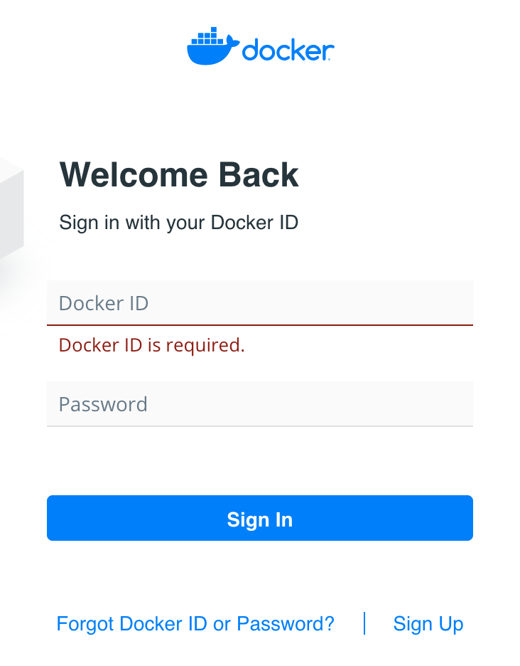

1. Fill up the details to create your Docker ID

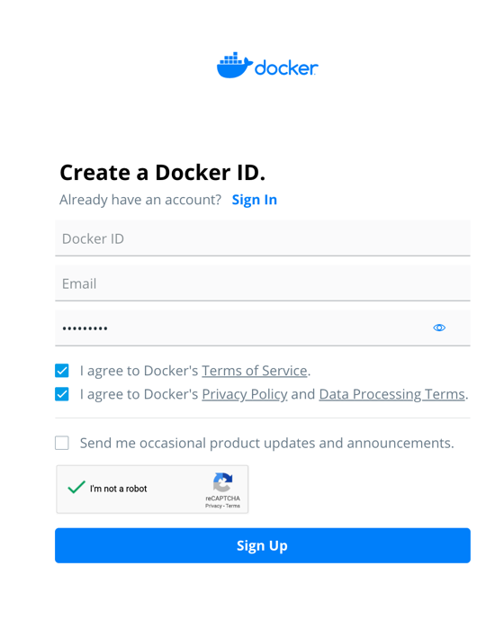

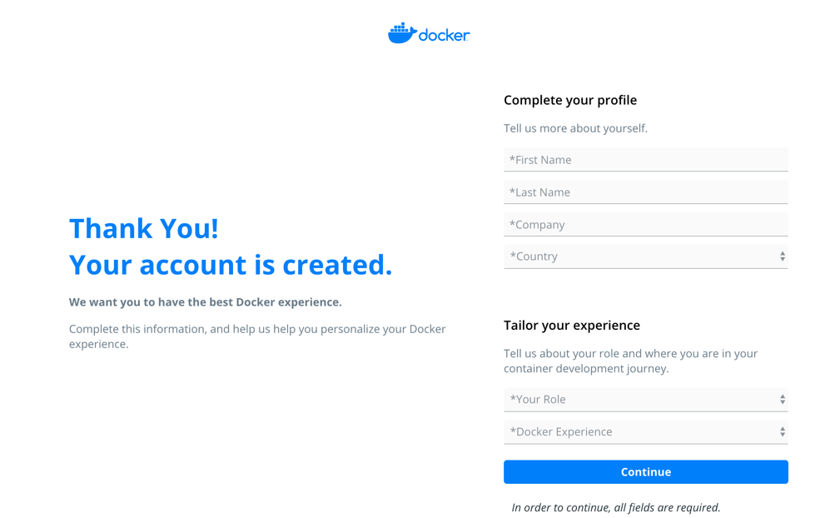

1. Go check your email once you finished completing your profile.

**Sign in to docker.com**

1. Go to <https://id.docker.com/login/>
2. Click Sign In



**Download and using Docker Desktop**

1. Go to <https://hub.docker.com/>
2. Click Download Docker Desktop for Mac / Windows depending on your operating system.

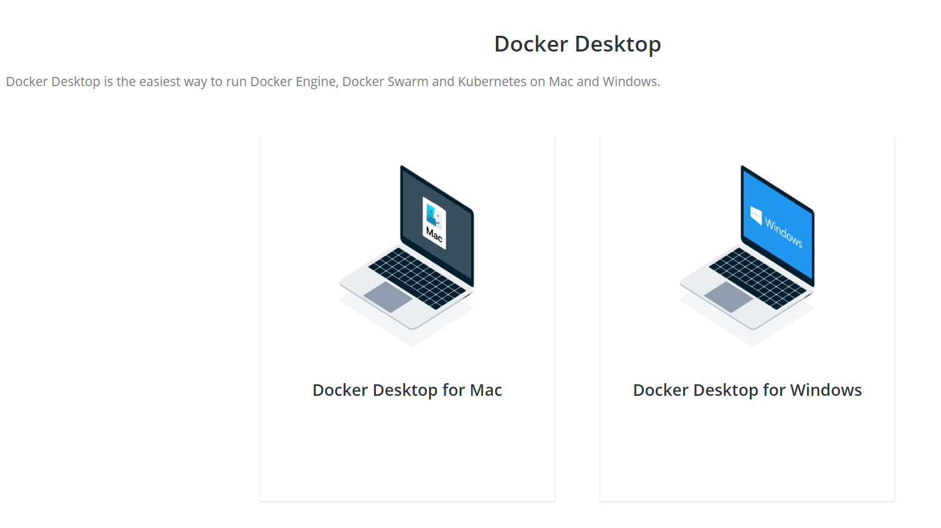

1. Follow the steps in the docker website.

**Note: the commands may differ due to different Docker IDs.**

1. **Download** step

Note: If the screenshot below did not appear, go to this link: <https://hub.docker.com/?overlay=onboarding>

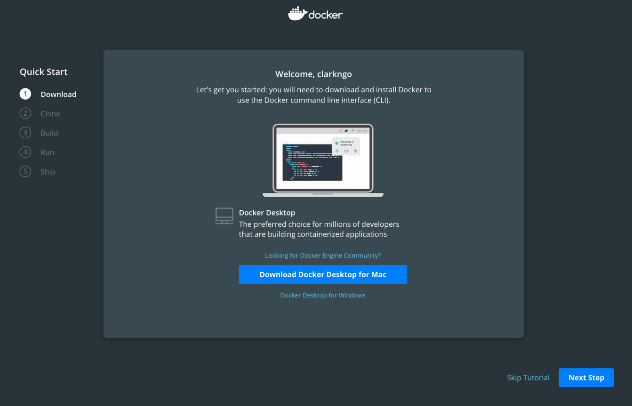

1. Once you finished installing, open upon a terminal (MacOS) or a command prompt (Windows OS).
2. **Clone** step

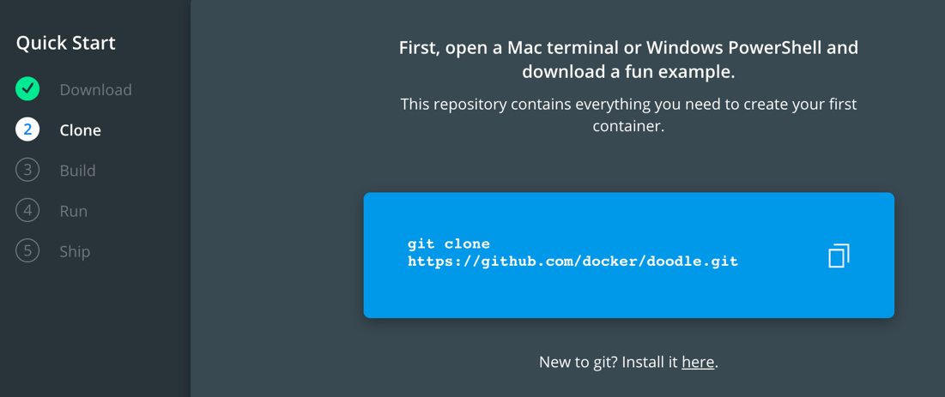

Example output in MacOS:

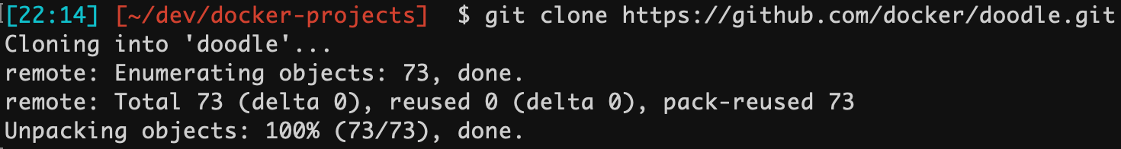

1. **Build** step

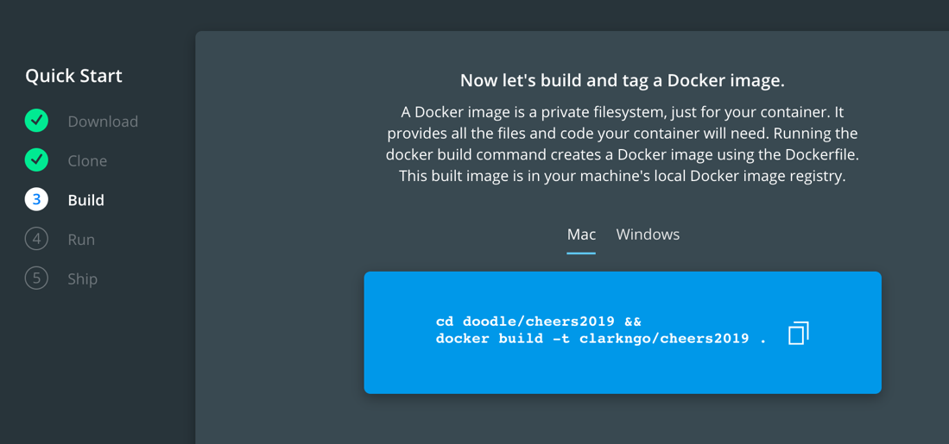

Example output in MacOS:

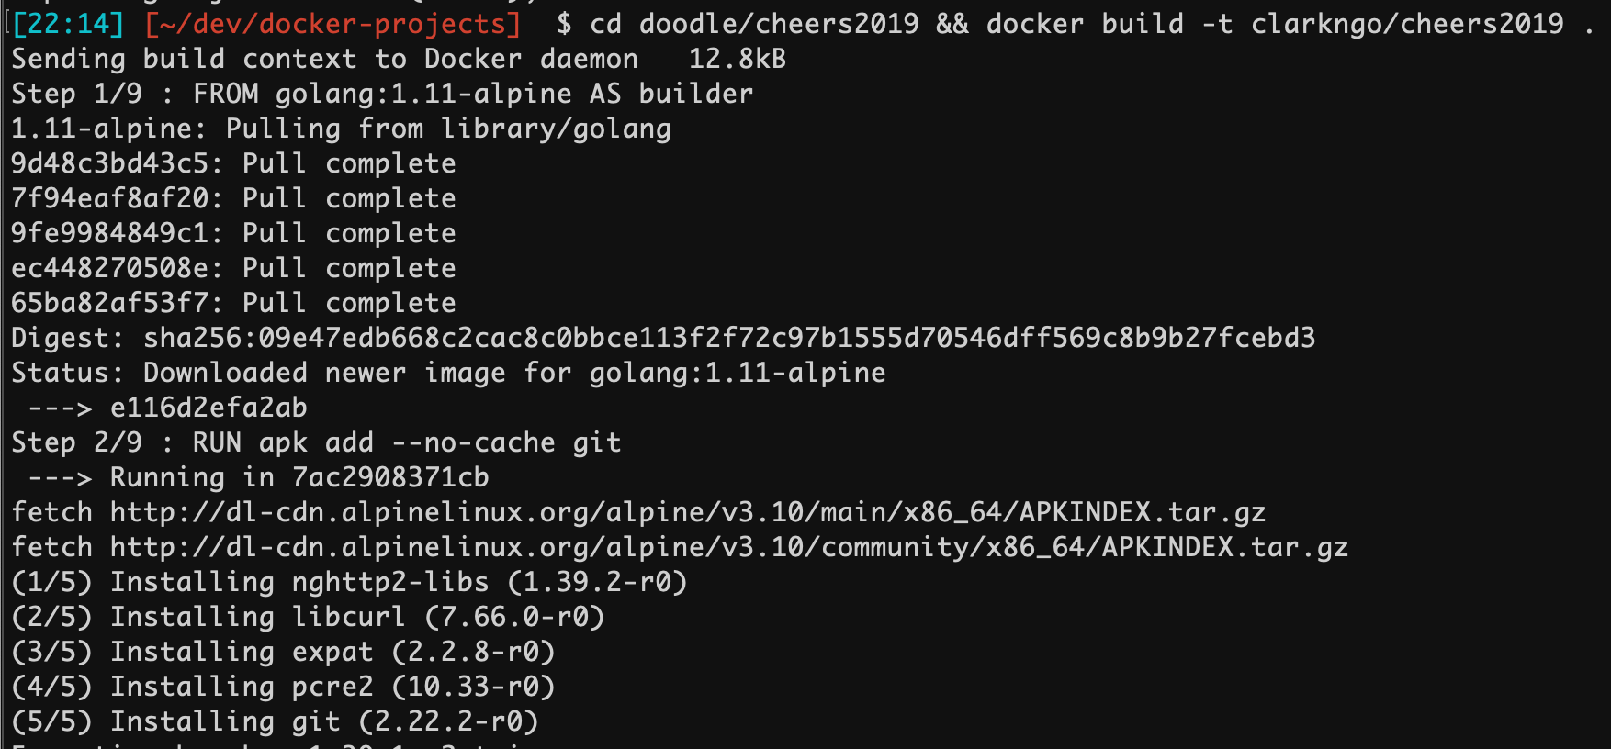

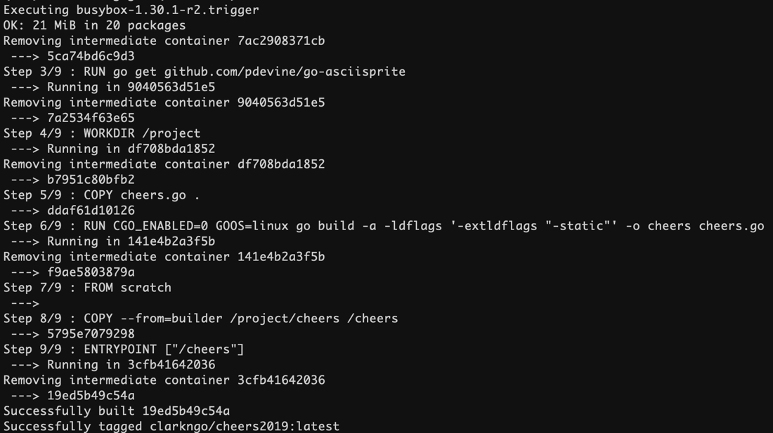

1. **Run** step

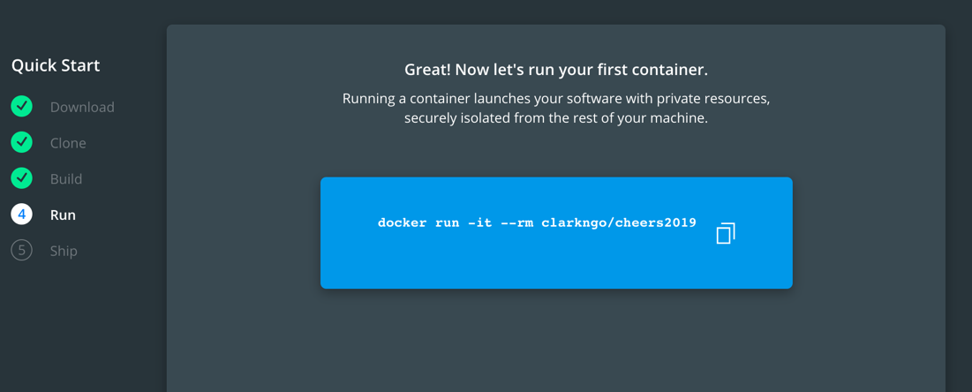

Example output in MacOS:





1. **Push** step

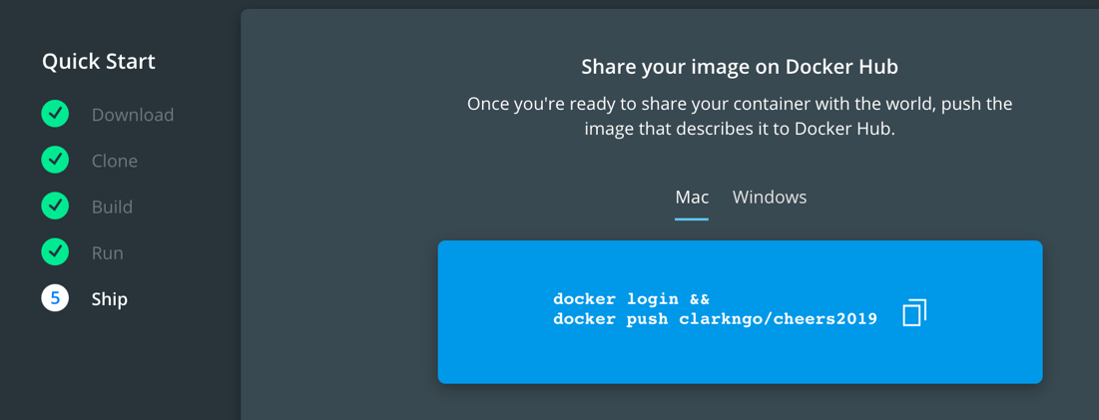

Example output in MacOS:

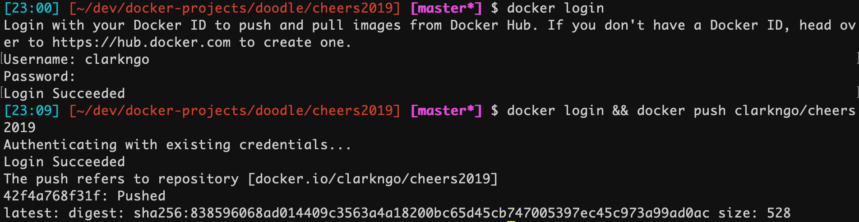

Common gotcha for MacOS:

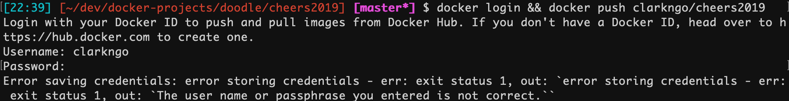

To fix this:

Try opening Keychain Access  
Right-click on the login keychain  
Lock it and then unlock it again

